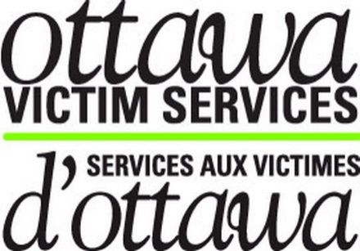

OVS

Annual Report

  - FY 2019-2020

Ottawa Victim Services provides emotional and practical support to those victimized by crime and tragic circumstances in the City of Ottawa
A message from our Board Chair,

On behalf of the Ottawa Victim Services Board of Directors, I would like to take this opportunity to express our sincere gratitude and appreciation to our staff and volunteers for all of the tireless hard work, time, dedication and compassion for others that you have provided over the last year to the organization and the hundreds of victims we support in our community. You continue to serve your community professionally – with heart and perseverance. Feel as proud of yourselves as we do of you because without you, the work of OVS fulfilling its mandate would not be possible.
To the Board of Directors, I extend a huge thank you on behalf of myself, the staff and the volunteers. Although your efforts are most commonly behind the scenes, you are an integral part of the organization providing leadership and support. I continue to be grateful for your time and dedication to OVS.
Thank you to our countless community partners who assist the staff and volunteers on a daily basis to ensure that the victims in our community who need support receive it in a timely and professional manner. OVS alone cannot support everyone with everything and it is a true collaboration that makes our work possible.
We continue to provide a holistic service to anyone in need and have supported hundreds of clients in 2019/2020. This year we have had many successes including:
- Supporting victims of crime and tragic circumstance throughout the City of Ottawa;
- Growing and further strengthening our partnership with the Ottawa Police Service and completing of our Agency Level Agreement; as well as adding new and exciting partnerships like that with the Human Trafficking community, the indigenous community, as well as multiple research projects with the Ottawa Hospital;
- Participating in countless community events fostering inclusion and raising the profile of OVS, including Capital Pride, Human Trafficking Awareness Day and multiple tabling events throughout the community;
Over the course of the past year, our staff has remained consistent with the addition of new team members. More than 70 new volunteers were trained to provide victim support. In spite of continued challenges, the OVS staff and volunteers, under the direction of our amazing Executive Director, have risen to the occasion and thrived in their efforts to continue to provide a vital service. I am honoured to serve as your Board Chair and look forward to the year ahead.
Alison Newson

A Message from our Executive Director,
The 2019-2020 year brought about significant change for OVS. We welcomed a new team to the agency who have proven in the last year how incredibly dedicated they are to working with, and supporting victims of crime in our community. We could not have achieved what we have this year without each of them. We were also met with great difficulty when our police contracts were held back when we were up for renewal and we lost the majority of our police stats during contract negotiations. We were faced with much difficulty this past year however we came out of it stronger and more willing than ever to over come the obstacles we faced. With our police contract now signed and referrals now flooding back in again we can get back to the amazing work we do everyday!
We are incredibly thankful to have maintained our funding levels with the Ministry of the Attorney General and want to thank them profusely for their patience and support during this past year. We also welcomed a funding increase for our VQRP+ program after the Criminal Injuries Compensation Board was dismantled. Although we would like to see continued funding and fair compensation without timelines for all victims of crime, we welcomed the funding increase to better support our agency and our team to process VQRP+ applications more diligently.
The fiscal year ended with us all moving into isolation as a global pandemic struck, but once again the OVS team came through for victims of crime by re-establishing a service delivery protocol that would work for everyone while they embarked on a work from home basis. We never in a million years could have anticipated or been prepared for something like this but I am proud to say our service levels were not impacted. This never could have been done without the dedication of our staff and volunteers and for this I am so incredibly thankful.
We would also like to express my gratitude to the Board of Directors for donating their time to help with the strategic vision and planning for the organisation. I couldn’t do what I do without their continued support and guidance.

Here’s to continued success, health, and prosperity for the 2020-2021 year,

Melissa Heimerl BA, M.Ed
Executive Director

Community Memberships

At OVS we truly value collaboration with our community partners. We are currently members of: Ottawa Coalition to End Violence Against Women (OCTEVAW), Crime Prevention Ottawa’s Connecting on Disability and Abuse (CODA), the Frontline Human Trafficking Committee, the Sexual Assault Network (SAN), the Sex Work committee, the Restorative Justice Committee and Ottawa Police’s LBGTQ Liaison Committee as well as their Sexual Assault/Domestic Violence Advisory committee. We also sit on the advisory committees for Algonquin College in the Victimology, Community & Justice Services, and Social Service Worker Programs. We welcomed placement students from Community and Justice Services, Social Services, Victimology, Social Work, and Criminology this past year. Thank you to all our students for the key roles they played in helping the agency this fiscal year!
We are also proud members of the Ontario Network of Victim Service Providers and our Executive Director continues to be one of the elected Eastern Ontario representatives on the Provincial board of directors. This fiscal year Ottawa hosted the Annual General Meetings and held a dinner on Parliament Hill. We also welcomed the Attorney General of Ontario and Chief Justice Barajas from the National Organisation for victim
VA to the nations Capital!

OVS would like to thank our community partners including the Ottawa Police Services, Victim Crisis Unit, Sexual Assault Partner Abuse Care Program, OCTEVAW, Victim Witness Assistance Program, Voice Found and many more for their continued support and referrals. We cannot thank you enough!

OVS Wish list

Like most non-profits our funding doesn’t always cover all of our agency needs. We continue to offer 911 cell phones and safety alarms to clients who are accessing our Victim Safety and Coordination Program. If you or someone you know has an old cell phone with a charger please consider donating it the agency. These costs can be quite high and we are in need of sponsorship, or donations, for these items.

Ottawa Victim Services (OVS) provides emotional support, practical assistance, referrals and advocacy to individuals who have been victimized as a result of a crime or tragic circumstance, without judgment in order to lessen the impact of victimization. OVS is a community-based agency committed to treating individuals with courtesy, compassion and with respect for their dignity, privacy and diversity. Clients can access our services through referrals from community service agencies, the Police or self-referrals.

OVS provides emotional support through the criminal justice system, helps clients identify their options and choices and provide information. OVS is also very active in providing practical assistance such as transportation, food sustenance and accompaniment to court or the police station. OVS works with many partners and regularly refers victims to community agencies, legal resources, medical support and Victim Assistance organizations that are out of our service area.

OVS Programs

The Victim Crisis and Referral Services (VCARS) – OVS volunteers, in partnership with VCARS staff assisting Police and community service providers, meet short-term practical and emotional needs of individuals who have been victimized as a result of a crime or tragic circumstance, and their longer-term needs by referral to appropriate existing community agencies. VCARS offers crisis intervention services to clients 24 hours a day, 7 days a week.

Victim Quick Response Program+ (VQRP+) provides timely financial assistance to eligible individuals who have been victimized by violent crime (homicide, attempted murder, serious physical assault, domestic violence, human trafficking, sexual assault and hate crime) and/or their family members. VQRP can help individuals who have been victimized by violent crime who require immediate financial assistance to access short-term counselling, funeral expenses for homicide victims; emergency home repairs to secure premises for victim’s safety, crime scene clean-up, emergency accommodation and meals, etc. We look forward to the 2019-2020 year where we will be introducing the VQRP + program to our community partners and survivors.

Victim Safety Coordination Program (VSCP)
-the program offers personalized safety planning and risk assessment, referrals for ongoing support and access to 911 cell phones and/or personal safety alarms. Safety planning is offered to high risk individuals who have been victimized by domestic violence, sexual assault criminal harassment, assault, break and enter, and human trafficking. All individuals qualify for safety planning.
The program also assists victims in accessing the Criminal Injuries Compensation Board application as well as assistance in filling out the forms and acquiring necessary supporting documentation. We also accompany clients to their hearings.

OVS-VCU Partnership Program
In 2015, OVS engaged in a partnership with the Victim Crisis Unit of Ottawa Police Service. An OVS Case Manager works out of the unit to transfer files directly to OVS based on a set triaging system. This partnership has led to the tripling of our agencies numbers and also means that more victims than ever before are being offered service in the Ottawa community. We look forward to continuing to grow this partnership to offer more services to victims of crime.

Community Events 2019-2020!
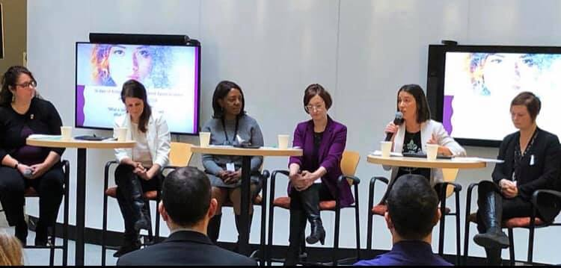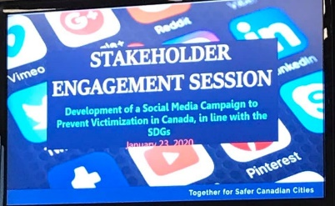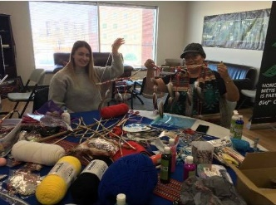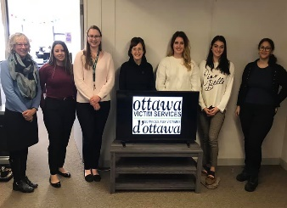
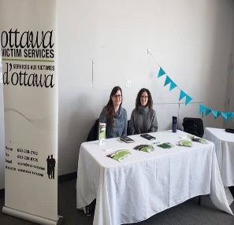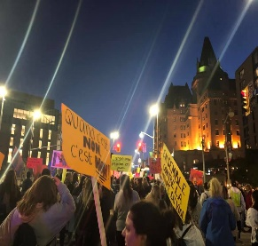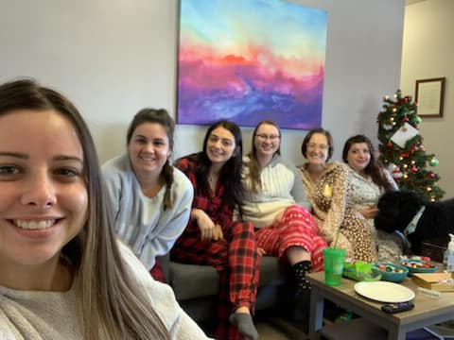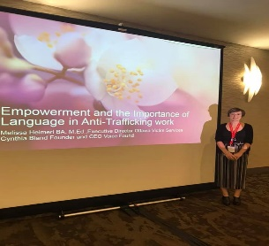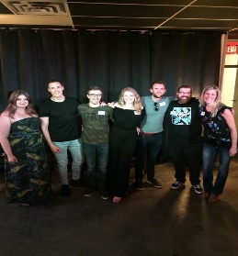
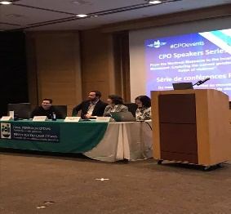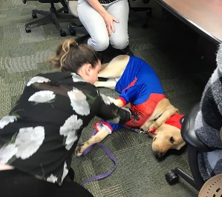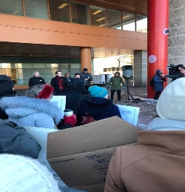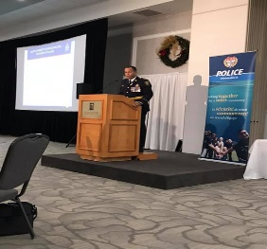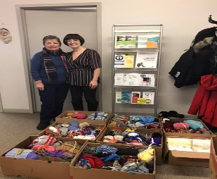
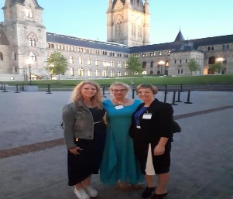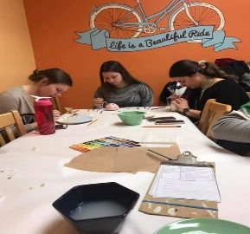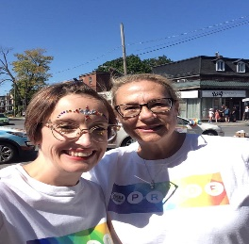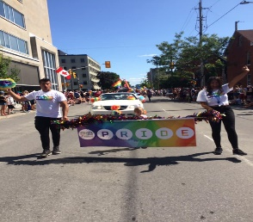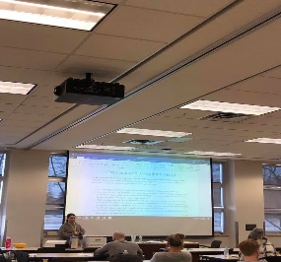
16 days of activism event for the Department of Justice (Melissa was a panelist on Gender Based Violence), Federal Ombudsman’s event, Indigenous Human Trafficking Day event, REACH Ottawa Presentation, Tabling event for Hope Closet, Take Back the Night, Staff xmas pic, RESET Conference (Melissa was a speaker), Team Leads at Volunteer Appreciation event, Crime Prevention Ottawa Event for the National Day of Remembrance, K9 West at Halloween, Emergency Housing protest, OPS Learning Forum (New Chief), Xmas donations for VAW shelters, Dinner on Parliament Hill, self care painting for staff, Capital Pride, Volunteer training. Thank you to everyone who participated in community events and for an amazing year!
Board of Directors Staff 2019-2020 year
Alison Newson – Chair Melissa Heimerl – Executive Director
Meagan Ann O’Hare-Gordon – Vice chair Marlene Trunzo – Office Manager & Book keeper
Ingrid Gingras – Secretary Madeline Miller – OVS-VCU Victim Support Worker
Sheila Hamilton – Treasurer Megan Sesely – VSCP Coordinator
Ken Bryden - OPS Liaison – Kristina Epifano - VCARS Coordinator
Wendy Schlachta – Community Member Kristen Piazza – VQRP Coordinator
Doug Macklem – Community Member Megan Sesely – VQRP Support Worker
Celina Arlotta – VQRP Support Worker
Cerena Habbouche - VQRP Support Worker
Jaqueline Pearson – Case Manager OVS-VCU
OTTAWA VICTIM SERVICES VOLUNTEER APPRECIATION DAY

September 24th, 2020
WHEREAS, Ottawa Victim Services staff and volunteers provide emotional support, crisis intervention, safety planning and referrals to those victimized as a result of crime or tragic circumstance; and
WHEREAS, Ottawa Victim Services volunteers are on call 24 hours a day, seven days a week; and
WHEREAS, Ottawa Victim Services volunteers support sexual assault, domestic violence, serious personal violence and break and enter victims and/or their family members; and
WHEREAS, Ottawa Victim Services has a unique partnership with the Ottawa Police Service Victim Crisis Unit that allowed volunteers to offer services to hundreds victims in the last year; and
WHEREAS, Ottawa Victim Services volunteers
provide a vital role in Ottawa, working in partnership with the city, the police and other community agencies to support those victimized by crime and tragic circumstances;
THEREFORE, I, Jim Watson, Mayor of the City of Ottawa, do hereby proclaim September 24th, 2020 Ottawa Victim Services Volunteer Appreciation Day in Ottawa.
JOURNÉE D’APPRÉCIATION DES BÉNÉVOLES DES SERVICES AUX VICTIMES D’OTTAWA
ATTENDU QUE Les services aux victimes d’Ottawa procurent un soutien affectif, effectuent des interventions en cas d’urgence et offrent des services de planification en matière de sécurité et d’aiguillage aux victimes de crimes ou de circonstances tragiques; et
ATTENDU QUE Les Service aux victimes d’Ottawa sont disponible 24 heures sur 24, sept jour sur sept; et
ATTENDU QUE Les Services aux victimes d’Ottawa offrent un soutien aux victimes d’agression sexuelles, de violence familiale, de la traite de personnes, de violence grave contre la personne, de crime de haineux et a ceux touchés de prés par une mort subite, ainsi què aux membres de leur famille, et
ATTENDU QUE Les services aux victimes d’Ottawa jouent un role essential a Ottawa, travaillant en association avec la ville, le service de police, les hopitales, et d’autre organisms communautaires afin de soutenir de centaines de victims cette annee;
PAR CONSÉQUENT, je, Jim Watson, maire de la Ville d’Ottawa, proclame par la présente le 24 septembre 2020 la journée d’appreciation des services aux victimes D’Ottawa à Ottawa.
Jim Watson
Mayor / Maire

2019-2020 BUDGET

Ottawa Victim Services Inc. Operations and Net Assets
Year ended March 31, 2020
2019 - 2020 2018 - 2019
$ $
Revenue
Contributions
Ontario Ministry of the Attorney General (MAG) 504,253 488,329
Employment and Social Development Canada
H.E.A.L.T.H. funding 4,000 8,000
Victims week 8,000
Crime Prevention Ottawa 6,116
Women Warriors Healing Garden 1,949 1,882
Shoppers Drug Mart 3,000
Fundraising and miscellaneous activities 5,354 2,228
515,556 517,555
Expenses
Salaries and benefits 351,280 369,420
Insurance 4,322 4,322
Rent 46,560 45,505
Staff expenses 11,876 9,330
Volunteer costs 9,194 9,977
Client expenses 8,229 6,798
Public education 1,139 2,961
Office 11,254 11,852
Communications 15,033 13,935
Professional fees 26,500 31,300
Membership fees 4,040 2,000
Bank charges 662 788
Advertizing and promotion 3,992 6,205
Board costs 2,107 3,038
Harmonized sales tax 4,749 4,165
Project and fundraising costs 5,982 18,857
Equipment purchases 3,793 2,888
Translation 404
Amortization of tangible capital assets 2,087
512,799 543,745
Excess (deficiency) of revenues over expenses 2,757 (26,190)
Net assets, beginning of year 41,575 67,765
Net assets, end of year 44,332 41,575
The accompanying notes are an integral part of the financial statements.

Thank you to all of our funders for the 2019-2020 year! We couldn’t do it without your support!

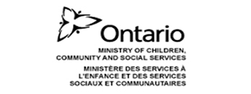 Thank you to all our funders this year!

